Zip Payments

SFRA Integration Guide

**Version <19.1.0>**





Contents

Summary 5

Components Overview 6

Functional Overview 6

Zip Processor 6

Zip Checkout 6

Zip Checkout Experience 6

Zip Payment Method 7

Zip Marketing 7

Use Cases 7

Checkout with Zip and Handle Zip Checkout Experience Outcomes 8

Control Available Zip products via min/max ranges 9

Handle Zip Checkout Experience cancellation. 9

Use tokens for delayed captures, order cancellations and refunds. 9

Checkout with New Zip Account Registration 9

Checkout with Zip Saved Payment method 10

Initiate Zip checkout experience as a redirect to a new page or a lightbox within the same page. 10

Advertise Zip support via Zip marketing features 10

Hook capture, refund and cancel 10

Limitations, Constraints 10

Implementation Guide 12

System Extensions 12

Payment Processors 12

Payment Methods 13

System Object Type Extensions 14

Services 18

Content Slots 19

Content Assets 19

Installation 20

Archive Contents 20

Archive Preparation 20

Cartridge Installation 20

Customizations and Extensions 22

Use Back-End Hooks To Capture and Refund Amounts 22

Testing 23

Checkout with Zip Standard Flow as Guest 23

Prerequisites 23

Visit website and Choose Locale 23

Add Product 24

Proceed to Checkout as Guest and Enter Shipping Information 24

Enter Billing Information and Choose Zip as Payment Method 25

View Payment Summary and Continue To Zip 26

Choose a Zip Product 27

Confirm Order with Zip 28

Check Order Confirmation Page 29

Check Confirmation Email 30

Check Order in Business Manager 31

Visit Zip Merchant Dashboard to confirm Order 33

Checkout with Zip standard flow as Customer 34

Prerequisites 34

Visit Website and Choose Locale 34

Add Product 35

Proceed to Checkout as Guest and Enter Shipping Information 36

Enter Billing Information and Choose Zip as Payment Method 37

View Payment Summary and Continue To Zip 38

Complete Order with Zip 39

Check Order Confirmation Page 40

Check Token in My Account 41

Checkout with an Existing Customer Token 42

Prerequisites 42

Complete billing step and Pay with Zip 42

Check Order Summary and Place Order 43

Check Order Confirmation 44

Operations, Maintenance 46

Data Storage 46

Zip Tokens 46

Availability 46

Support 46

User Guide 47

Business Manager 47

Configure Zip Payments Processor 47

Configure Zip Payment Method 47

Configure Zip Marketing 48

Configure Zip Checkout 49

Configure Thank You Page (Order Confirmation) 50

Configure Zip API Client 50

Known Issues 52

Release History 53

# Summary

**ZipMoney SFRA** is a cartridge built for SFRA-based sites which allows customers to select Zip payment method and place orders using one of many Zip Products.

The integration encompasses deployment of the cartridge. There are no further modifications on storefront explicitly required for the cartridge to run.

# Components Overview

## Functional Overview

### Zip Processor

This component is used to handle payments including authorizations, captures and refunds. Zip allows partial captures and partial refunds as well.

### Zip Checkout

This component is used to extend and customize the SFRA checkout with additional features to allow checking out using Zip Checkout Experience.

### Zip Checkout Experience

This component is provided by Zip upon checking out. It can be loaded as a stand-alone page or an in-page lightbox.

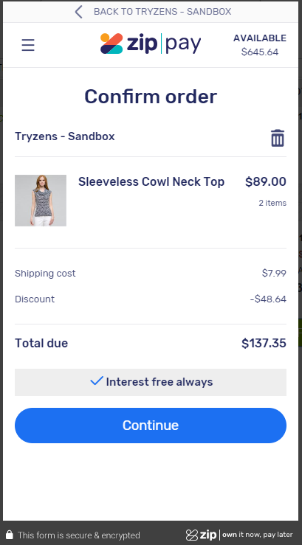

Zip Checkout Experience, Lightbox Mode

The Zip Checkout Experience allows a customer to choose a Zip Product, login with an existing account (or opt for a new one) with that product and attempt to complete checkout.

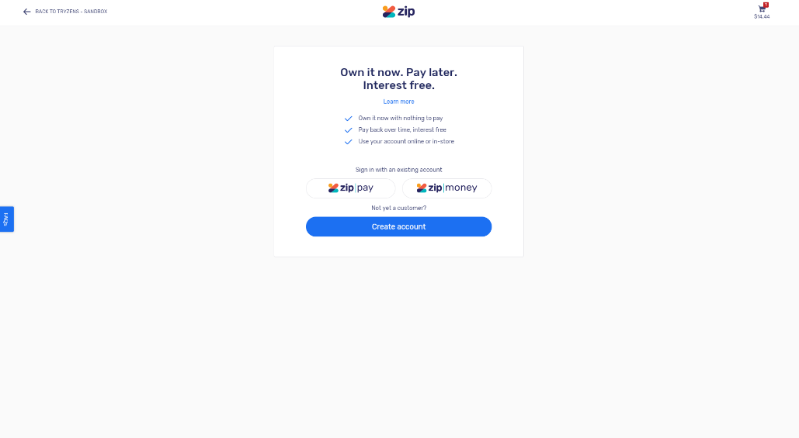

Zip Checkout Experience, Stand-Alone Page

Zip reviews the order and redirect to the merchant’s system with information as to whether the order has been approved or denied.

### Zip Payment Method

This component is used to show Zip as a payment method in checkout and allow customers to choose Zip as a payment method.

### Zip Marketing

This component is used to display marketing features including landing page, widgets, etc.

## Use Cases

The integration described in this document supports the following features:

* Checkout with Zip and Handle Zip Checkout Experience Outcomes
* Control Available Zip products via min/max ranges.
* Use tokens for delayed captures, order cancellations and refunds.
* Checkout with New Zip Account Registration
* Handle Zip Checkout Experience cancellation.
* Handle Order Denial/Recoverable Errors.
* Checkout with Zip Saved Payment method
* Initiate Zip checkout experience as a redirect to a new page or a lightbox within the same page.
* Advertise Zip support via Zip marketing features

This section describes all the features listed above in detail.

### Checkout with Zip and Handle Zip Checkout Experience Outcomes

A customer visiting the merchant’s website may attempt to checkout with one of the available Zip products: ZipPay or ZipMoney by completing an enhanced SFRA checkout. On the payment checkout stage, the customer can selected one of available Zip products:

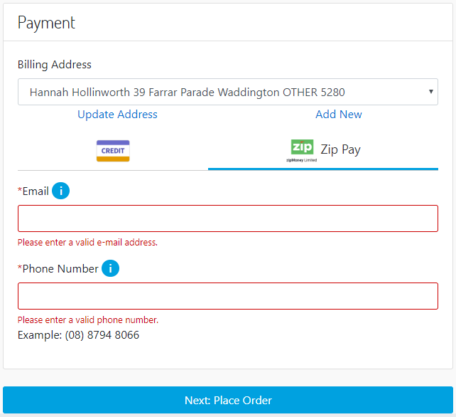

The order review stage has been enhanced with a Zip-specific button “Continue to Zip”, which when clicked will attempt to create and initiate a new Zip Checkout Experience and create a new order within the merchant’s system with status CREATED.

In case of order approval, the integration will attempt to place the order which will change the order’s status to NEW and authorize a new payment by creating a new charge via Zip API.

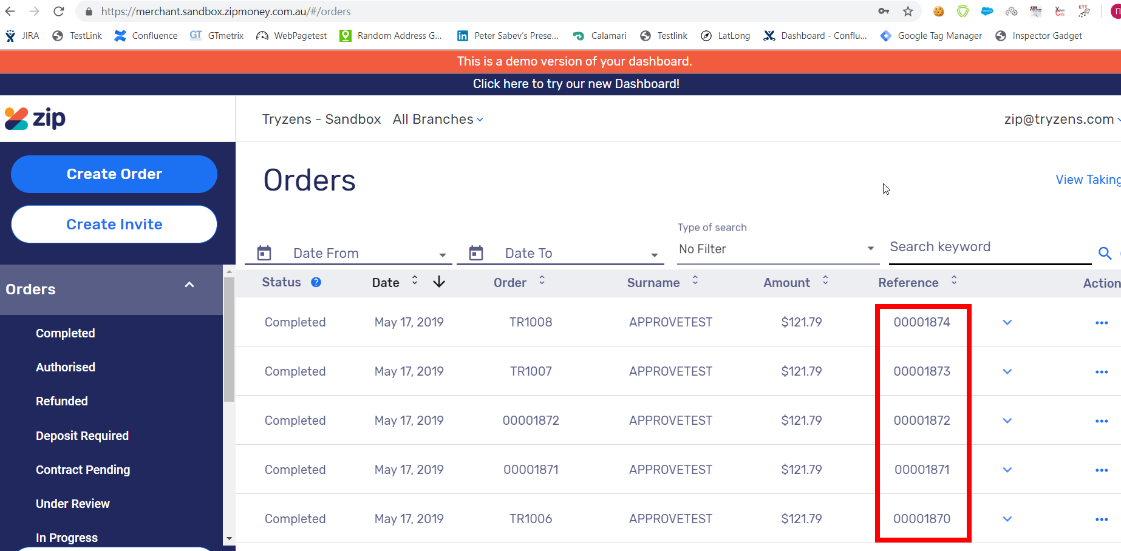

The orders are available in Zip’s merchant dashboard. The “Reference” column holds order numbers generated by the Salesforce platform. The “Order” column holds numbers generated by Zip. The “TR” prefix corresponds to tokenized orders.

If the merchant has enabled automatic capture, the payment amount associated with the newly created charge is also captured. If not, the integration will redirect the customer back to the checkout’s order review stage and show a standard error message. The customer may then attempt to complete a new Zip Checkout as the “Continue to Zip” button is going to be enabled.

### Control Available Zip products via min/max ranges

The merchant can control Zip applicability via per-currency min/max range.

### Handle Zip Checkout Experience cancellation.

A customer can cancel the Zip Checkout Experience by clicking a link within. If the merchant has enabled lightbox, it will close. If not, the customer is redirected back to the SFRA checkout’s order review stage. Either way, the customer can attempt a new Zip Checkout Experience on the same page.

### Use tokens for delayed captures, order cancellations and refunds.

The merchant can activate tokenization which allows the system to keep a token within a successfully created order. Later on, charges can be created, and payment amounts may be captured or refunded without customer’s involvement using the order’s token. Note that the created token does not expire.

The basic checkout creates a new checkout experience which later, when handling checkout completion/cancellation redirect, is used to create charges. This “checkout with tokenization” is a type of checkout which uses a token to create charges. The token is available for further captures and refunds for an order. The merchant can activate tokenization for each one of the Zip products to allow this payment flow.

### Checkout with New Zip Account Registration

A customer’s registration request may be approved within the same customer session (in a matter of seconds) or, it may require a manual approval. In case of manual approval, a Zip Agent will review the registration request and either approve or deny it. If the request has been approved, an email is sent to the customer with a link to finish the checkout process.

### Checkout with Zip Saved Payment method

This use case is applicable only for logged in customers. An additional checkbox is available when a Zip payment method is selected “Save payment method for future use”. The customer continues with checkout as usual. If the order is approved as a result of completing the Zip checkout experience, a new token is going to be requested via the ZIP API and saved to the customer’s profile.

Later on, the token is used anytime the customer attempts to place an order, bypassing the need for a new Zip checkout experience altogether. On the final checkout stage, the button will read “Place Order”.

The token will be available in “My Profile” section where customers can remove the token should they want to discontinue using it.

### Initiate Zip checkout experience as a redirect to a new page or a lightbox within the same page.

The merchant can choose if the Zip Checkout Experience is to be loaded within an in-page lightbox. If the lightbox is not enabled, the Zip Checkout Experience is loaded via a page redirect instead.

### Advertise Zip support via Zip marketing features

Merchant can enable/disable the following Zip marketing features:

* Product Description Page marketing link which, when clicked, opens the Zip Marketing Widget Popup.
* Cart Page marketing link which, when clicked, opens the Zip Marketing Widget Popup.
* Footer link which leads to an external Zip Landing Page loaded inline.
* Footer icon signifying website Zip payments support.

### Hook capture, refund and cancel

Merchant can programmatically hook to capture, refund and cancel charge. To do that, the merchant needs to disable automatic capture. When automatic capture is disabled, the charges are just authorized. Later, the merchant can use the hooks to trigger multiple captures of a single charge (partial capturing), refunds and charge cancellation.

## Limitations, Constraints

Zip currently supports only Australia and New Zealand; other countries are not supported.

Multi-shipping orders are not supported.

# Implementation Guide

## System Extensions

### Payment Processors

The system has been extended with a new payment processor: **Zip.**

**Settings are accessible here: “**Merchant Tools – Ordering – Payment Processors – Zip – Settings**”.**

|  |  |  |
| --- | --- | --- |
| **Setting** | **Value** | **Description** |
| Lightbox  (zipLightbox) | Yes/No | If turned on, ZIP will open in lightbox; false - ZIP will simply redirect to URL in the same page.  Default: No |
| Zip API Mode Production | Yes/No | If set to yes, the Zip API Client will load the Zip Production Service Profile. If no, Zip API Client will load the Zip Sandbox Service Profile. |
| Zip Tokenization  (zipTokenization) | Yes/No | Enable/disable tokenization for this processor.  Default: Yes |
| Zip API Key  (zipApiKey) | String | API Key for this payment processor. |
| Automatic Capture  (zipAutoCapture) | Yes/No | Enable/disable automatic captures of charges for this processor.  Default: Yes |
|  |  |  |
|  |  |  |
|  |  |  |

### Payment Methods

A payment method has been added: **Zip**, linked to the payment processor described in previous section.

|  |  |  |
| --- | --- | --- |
| **Setting** | **Value** | **Description** |
| Payment Processor | Zip |  |
| Countries | AU, NZ | This payment method is applicable for Australia and New Zealand by default.  Selected Countries: AU, NZ. |
| Min/Max Payment Ranges |  | The merchant can set a specific range for which Zip is applicable as a payment method. |

### System Object Type Extensions

#### SitePreferences

Custom preferences have been added to a new “**Zip**” group. Those preferences apply to the zip integration (they are not per-processor).

|  |  |  |
| --- | --- | --- |
| **Preference** | **Values** | **Description** |
| Zip Marketing Environment (zipMarketingEnvironment) | Sandbox / Production | Environment for Zip Marketing Widget.  Default: Sandbox |
| Zip Marketing Key (zipMarketingKey) | String | Zip Marketing Key. |
| Zip Pending Message Styles (zipPendingMessageStyles) | String | Custom CSS styles for the message appearing on confirmation page when an order has been placed with a pending referral application.  Default:  color: #6a0000; background-color: #f5cccc; border-color: #f1b8b8; |

#### CustomerPaymentInstrument

|  |  |
| --- | --- |
| **ID** | **Description** |
| Zip Token  (zipToken) | Used when tokenization has been turned on and an order has been approved. Before placing the order, a new token is created and saved in this attribute for the specific order. Later, the token may be used to create charges for this specific order. |

#### Order

The following custom attributes have been added to a “Zip” attribute group:

|  |  |
| --- | --- |
| **ID** | **Description** |
| Zip Token  (zipToken) | Used when tokenization has been turned on and an order has been approved. Before placing the order, a new token is created and saved in this attribute for the specific order. Later, the token may be used to create charges for this specific order. |
| Zip Require Approval  (zipRequireApproval) | Flag to indicate if the Zip order is linked to a customer account which requires approval. |

#### OrderAddress

AU and NZ are added as allowed countries in this system object type so they appear as valid values for selection within the payment method’s configuration settings.

|  |  |
| --- | --- |
| **ID** | **Description** |
| Country (countryCode) | Allowed countries for billing address (see the Countries setting within the ZIP Payments payment method).  Values:   |  |  | | --- | --- | | United States | US | | France | FR | | Italy | IT | | Japan | JP | | China | CN | | United Kingdom | GB | | Australia | AU | | New Zealand | NZ | |

#### OrderPaymentInstrument

The following custom attributes have been added to a “Zip” attribute group:

|  |  |
| --- | --- |
| **ID** | **Description** |
| Zip Email  (zipEmail) | This field holds the Zip email, which a customer entered when checking out with one of the available Zip payment methods. The field is shown in the order’s payment tab in BM. |
| Zip Phone  (zipPhone) | This field holds the Zip phone, which a customer entered when checking out with one of the available Zip payment methods. The field is shown in the order’s payment tab in BM. |

#### PaymentTransaction

The following custom attributes have been added to a “Zip” attribute group:

|  |  |
| --- | --- |
| **ID** | **Description** |
| Zip Capture Id  (zipCaptureId) | Holding Zip captured id. |
| Zip Refund Result  (zipRefundResult) | List of refund response results after refund request. |
| zipCaptureResult | Holding capture response result after capture request. |
| ZipCancelResult | Holding cancel response result after cancel request. |
| isZipAutoCapture | Holds the state of AutoCapture param in the capture request. |

#### Profile

The following custom attributes have been added to a “Zip” attribute group:

|  |  |
| --- | --- |
| **ID** | **Description** |
| Zip Token  (zipToken) | The token is saved to the customer’s profile when an order has been approved and the customer has opted to save zip payment method for future transactions. The token is used anytime the customer attempts to place an order, bypassing the need for a new Zip checkout experience altogether. The token will be available in “My Profile” section where customers can remove the token should they want to discontinue using it. |
| Zip Save Token  (zipSaveToken) | A flag programmatically set if the customer wants to save a Zip token. |

### Services

An HTTP service has been added: “zip.http.defaultendpoint” with a profile “zip.http.service” and two credentials: “zip.http.credentials.production” and “zip.http.credentials.sandbox” for each API mode respectively.

### Content Slots

Two new slots have been added:

|  |  |
| --- | --- |
| **Page** | **Slot** |
| Cart Page | zip-cart |
| PDP Page | zip-pdp |

Each one has a slot configuration added, linked to an HTML template with code that loads the Zip marketing widget.

### Content Assets

Two content assets have been added to “*SFRASharedLibrary*”.

|  |  |
| --- | --- |
| zip-declined | This message appears when a Zip payment has been declined. |
| zip-footer-link-text | Text of the footer link leading to the landing page. |

## Installation

This section describes the contents of the archive you downloaded from Salesforce as well as the way to prepare and install the archive to support payments with Zip.

## Archive Contents

The archive contains the following folders within:

* “build” – contains front-end build tools and configuration scripts. Note that, building the cartridge front-end resources is unnecessary as they have been added to the archive as well.
* “cartridges” – contains the Zip integration cartridges.
* “cartridges/int_zippay_sfra” – contains SFRA and system code extensions.
* “cartridges/bm_zippay” – contains Business Manager UI BM-related system extensions to help with QA testing and validating delayed payment flows (partial/full refund and capture of charges).
* “documentation” – contains this “SFRAIntegrationGuide.docx” document which describes integration of Zip Payments with the SFRA.
* “metadata” – contains meta-data to be imported when installing the cartridge.

## Archive Preparation

Before following the installation process in this section, please copy-paste the metadata folder in a temporary directory if your choosing. Then, follow these steps to ensure the archive is prepared for site import:

1. Within the site-template/sites directory, there is the SFRA folder. Rename the folder so its name corresponds to the name of your SFRA site onto which you want the cartridge installed. For example, if you have a site called RefArch, you have to rename the SFRA folder into a new folder called RefArch in the same directory.
2. Within the site-template/Libraries directory, there is the SFRASharedLibrary folder. Copy-paste the folder into a new one whose name corresponds to the <your-library-id> content library assigned to your site.
3. Then, within the site-template/Libraries/<your-library-id> directory, open library.xml file and look to find library-id="SFRASharedLibrary" at the first opening tag. Replace that with the name of your library <your-library-id>.

Note that if you have more than one sites onto which you want the cartridge installed, you have to follow the same steps and just copy-paste the folders.

## Cartridge Installation

Please, make sure the archive contents you received corresponds to the one described in “Archive Contents” and that you have followed the steps in “Archive Preparation” first.

Cartridge installation is done via following the steps laid out in the installation plan shown below:

1. Add currencies (AUD, NZD).
2. Add Locales (AU, NZ) – the AU and NZ locales need to be configured.
3. Import cartridge metadata via site import – the system integration expert is required to import metadata via “Site Import/Export” section in the business manager. Beforehand, the “sites/SFRA” folder may need to be renamed or duplicated so configuration is applied to the right site(s), based on SFRA, within the site structure of the merchant’s system.
4. Update cartridge path – for each SFRA-enabled site which is going to support zip payments, the system integration expert needs to prepend zip cartridge name to the cartridge path. In other words, “int_zippay_sfra” needs to come before “app_storefront_base” in the path.

## Customizations and Extensions

### Use Back-End Hooks To Capture and Refund Amounts

Define a hooks.json file in a cartridge with the following contents:

{

"hooks": [

{

"name": "zippay.order.processor",

"script": "./../int_zippay_sfra/cartridge/scripts/hooks/zip/orderprocess"

}

]

}

To implement a full capture, please use this line of code:

HookMgr.callHook('zippay.order.processor', 'CaptureFull', orderNo);

(if a partial amount has already been captured, this functionality will capture the amount not captured yet)

For partial order captures, please use this line of code:

HookMgr.callHook('zippay.order.processor', 'Capture', orderNo, amount);

(passing an amount equal to the amount not captured yet for this order will result in a full capture)

To implement a full refund, please use this line of code:

HookMgr.callHook('zippay.order.processor', 'RefundFull', orderNo, reason);

(if a partial amount has already been refunded, this functionality will refund the amount not refunded yet)

Order refunds can be implemented by using the following line of code:

HookMgr.callHook('zippay.order.processor', 'Refund', orderNo, amount, reason);

(passing an amount equal to the amount not refunded yet for this order will result in a full refund)

# Testing

## Checkout with Zip Standard Flow as Guest

The most basic test is a checkout by a guest user, going through the Zip standard flow. We are going to use the global site “*RefArchGlobal*” to complete the test.

### Prerequisites

As a prerequisite to the test, we must enable auto-capture and lightbox. Check out the screenshot below:

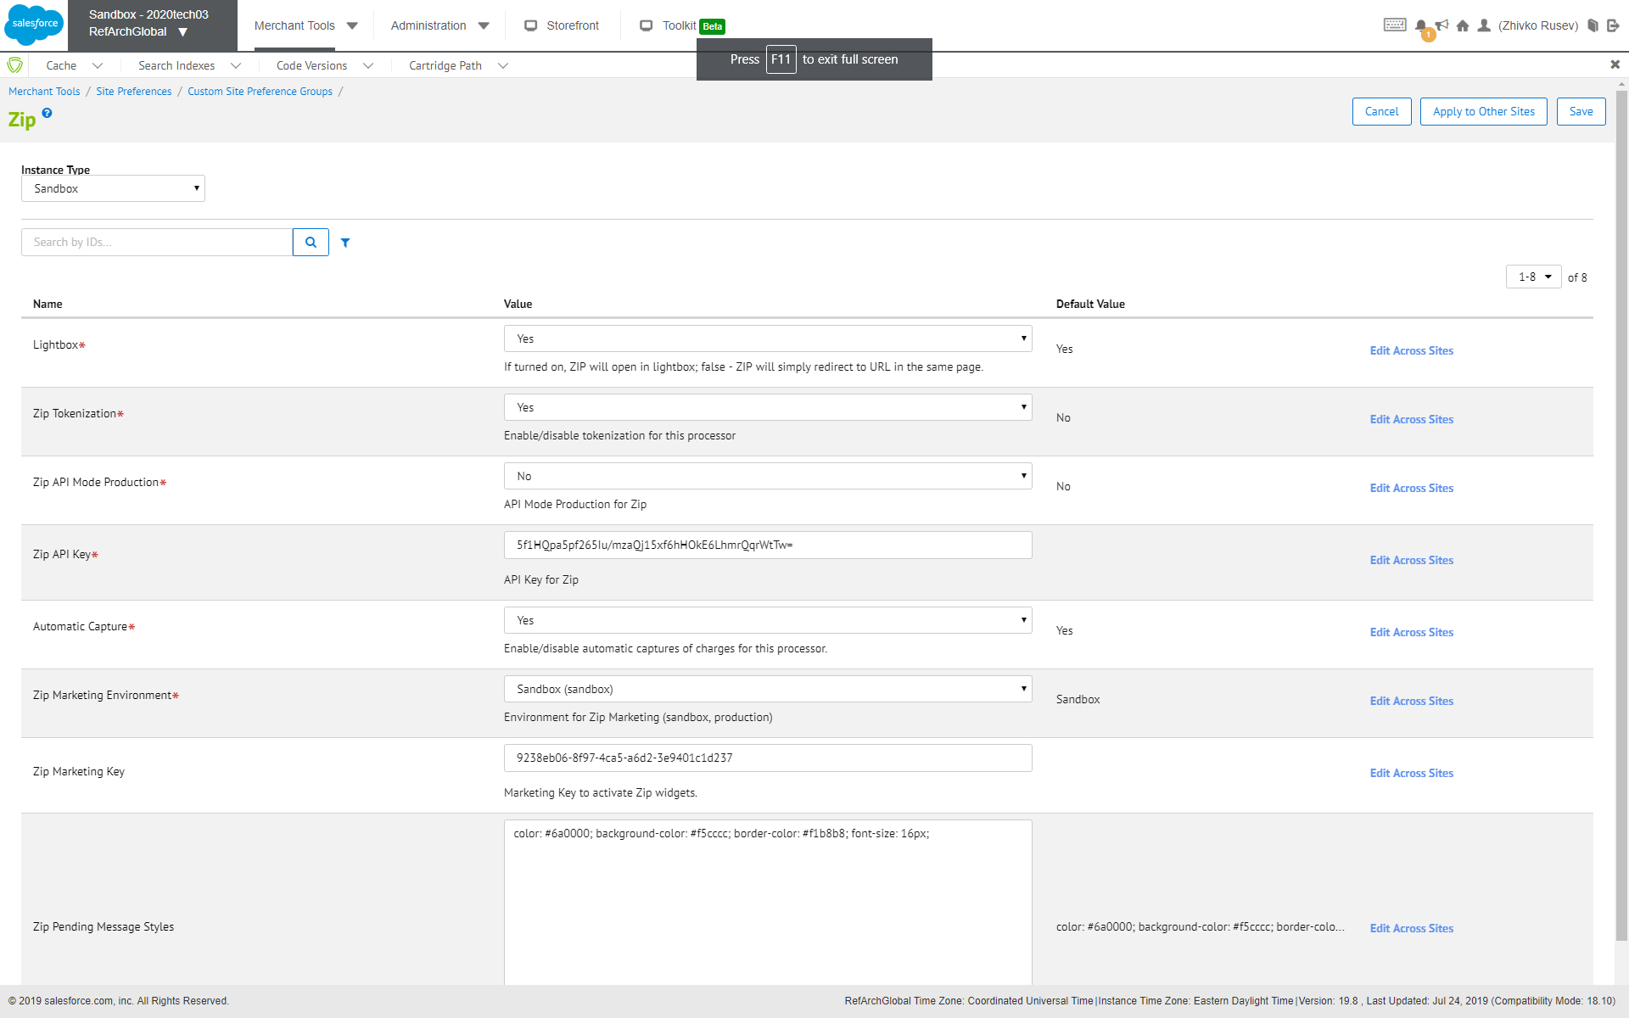

### Visit website and Choose Locale

Once the configuration is done in the Business Manager, you should visit the website. Zip is available for certain countries only. For this test, we are using the “*English (Australia)*” locale from the drop-down.



### Add Product

We have selected a simple product from a category “*Mens – Clothing – Suits*”. We have added 1 to cart.

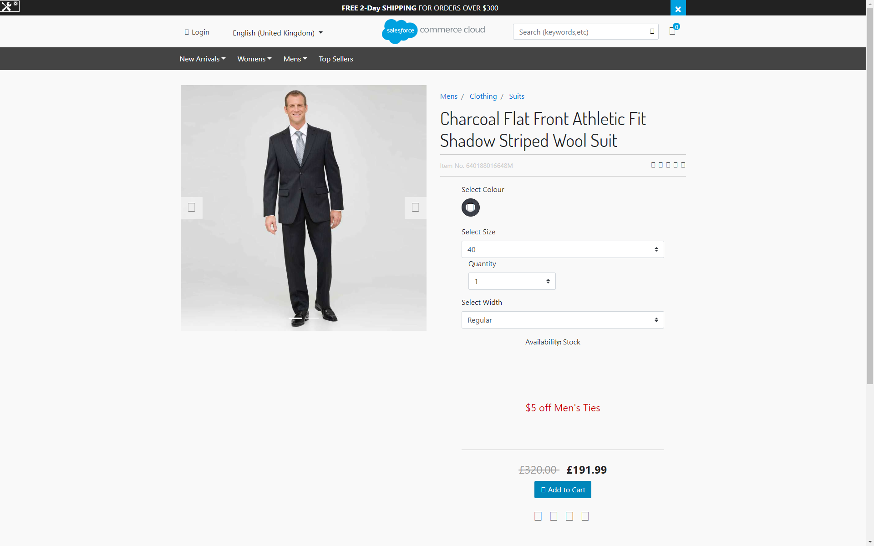

### Proceed to Checkout as Guest and Enter Shipping Information

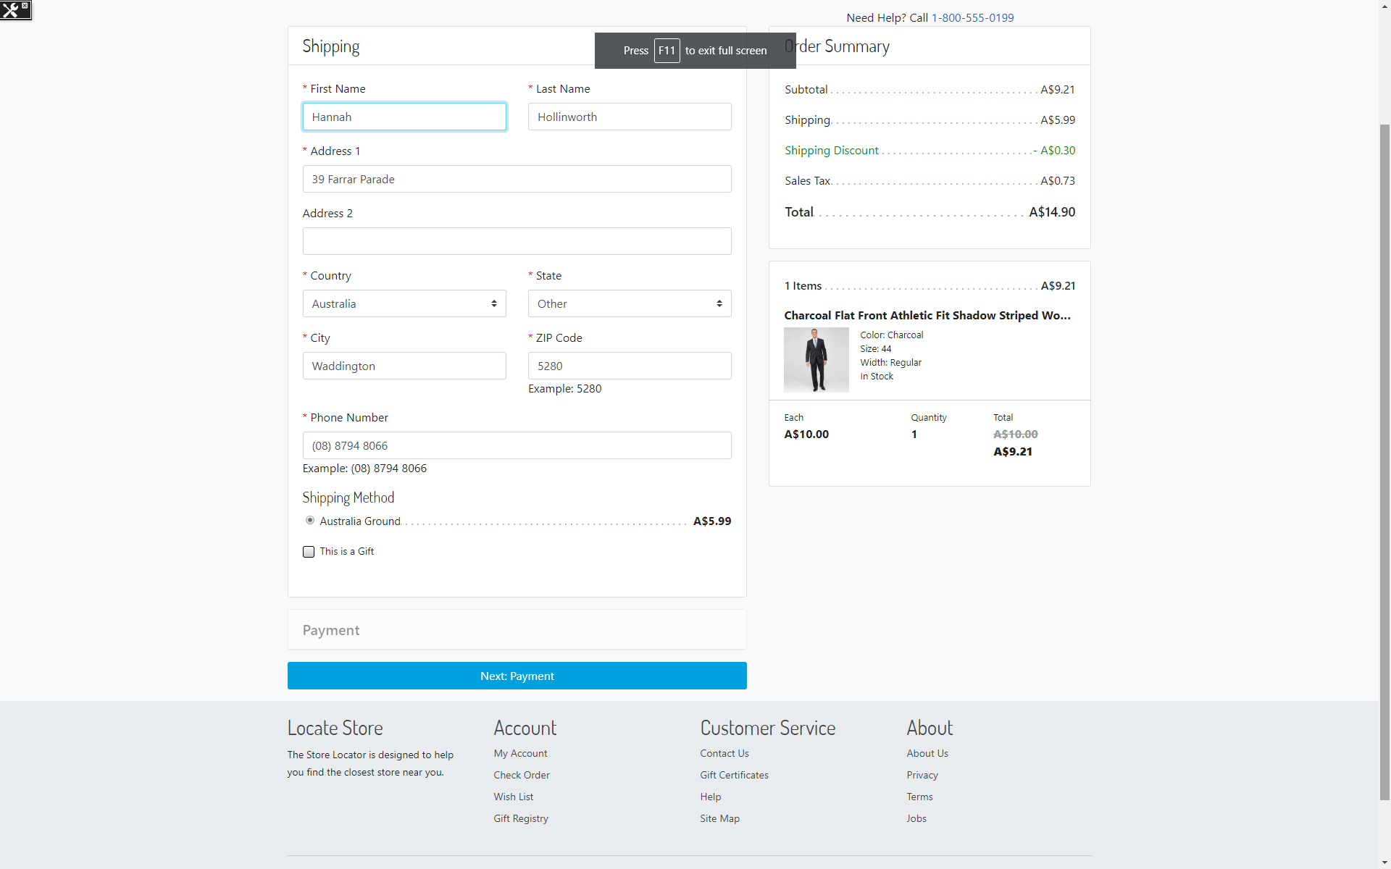

We used the following test address:

|  |  |
| --- | --- |
| First Name | Hannah |
| Last Name | Hollinworth |
| Address 1 | 39 Farrar Parade |
| Country | Australia |
| State | Other |
| City | Waddington |
| Zip Code | 5280 |
| Phone Number | (08) 8794 8066 |

Any shipping method should work. For the test, we are using *Australia Ground*.

When done, click “*Next: Payment*”.

### Enter Billing Information and Choose Zip as Payment Method

On the billing step, if everything has been configured correctly, Zip should appear as a payment method.

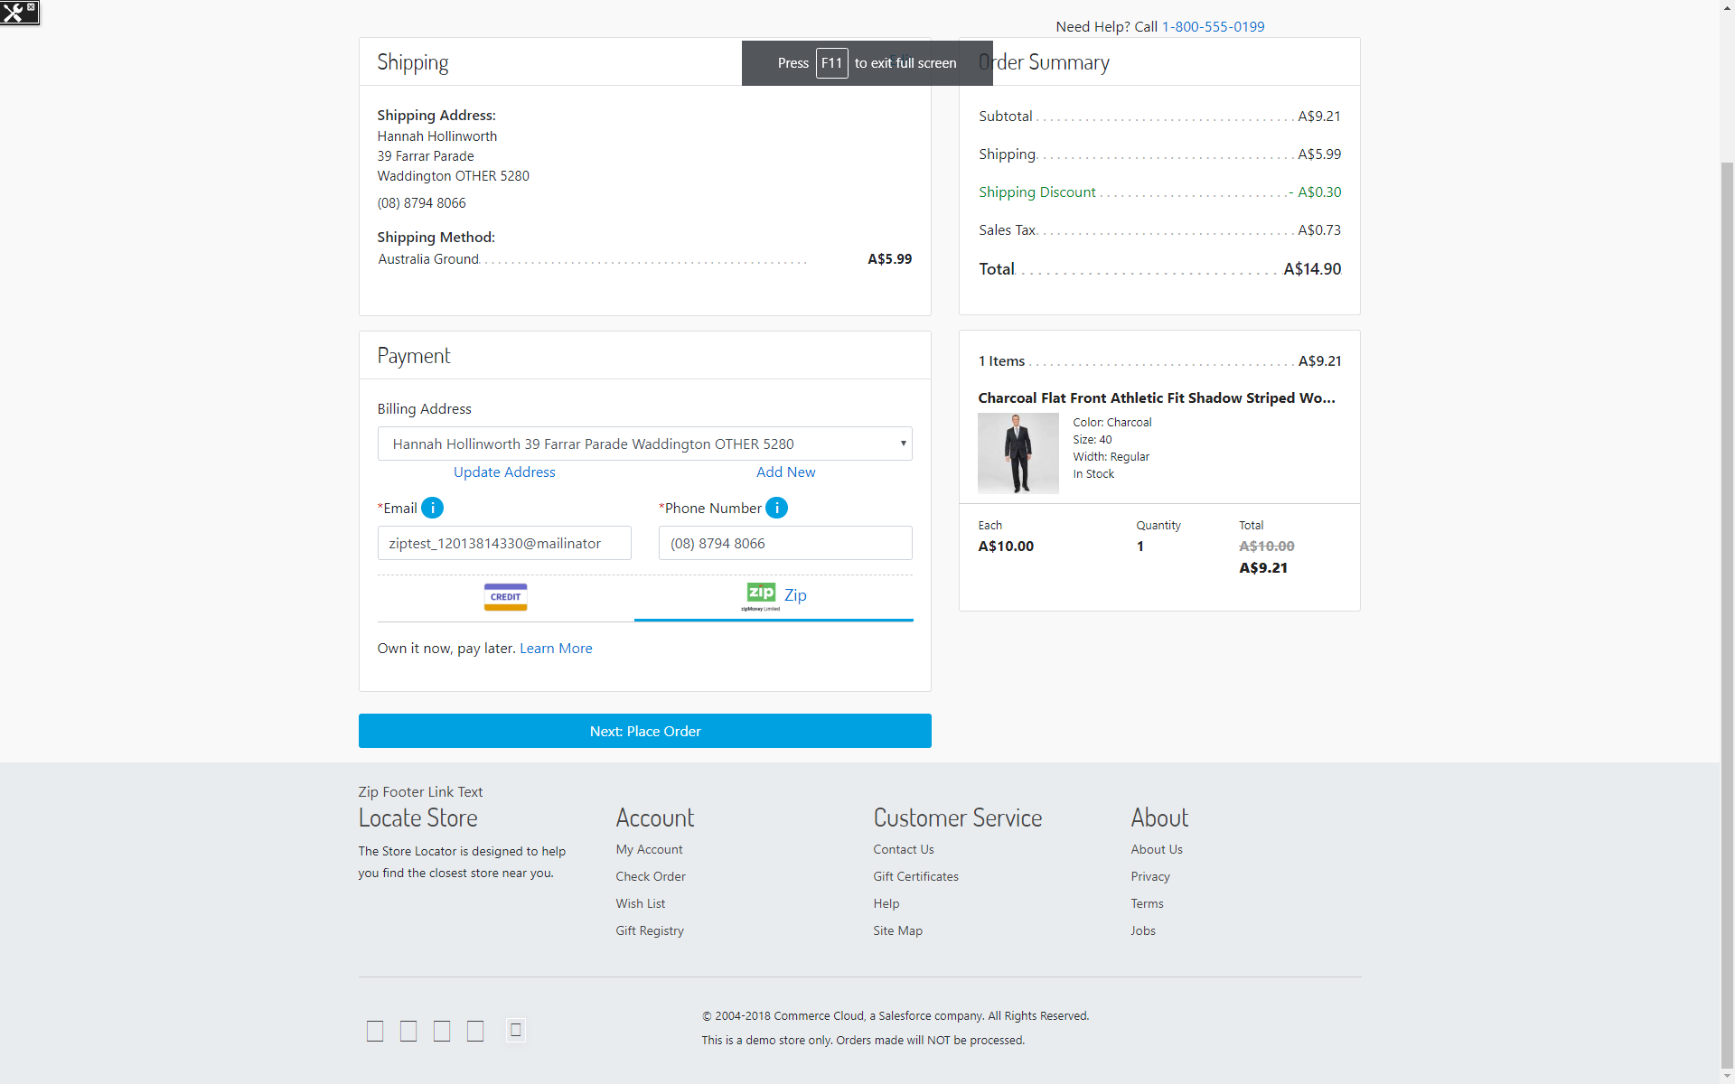

Enter an email and a phone number.

We used the following test phone and email:

|  |  |
| --- | --- |
| Phone Number | (08) 8794 8066 |
| Email | ziptest_12013814330@mailinator |

Choose Zip payment method.

Click “*Next: Place Order*”.

### View Payment Summary and Continue To Zip

On the payment summary step, the payment is “Zip” and there should be a button “*Continue To Zip*”.

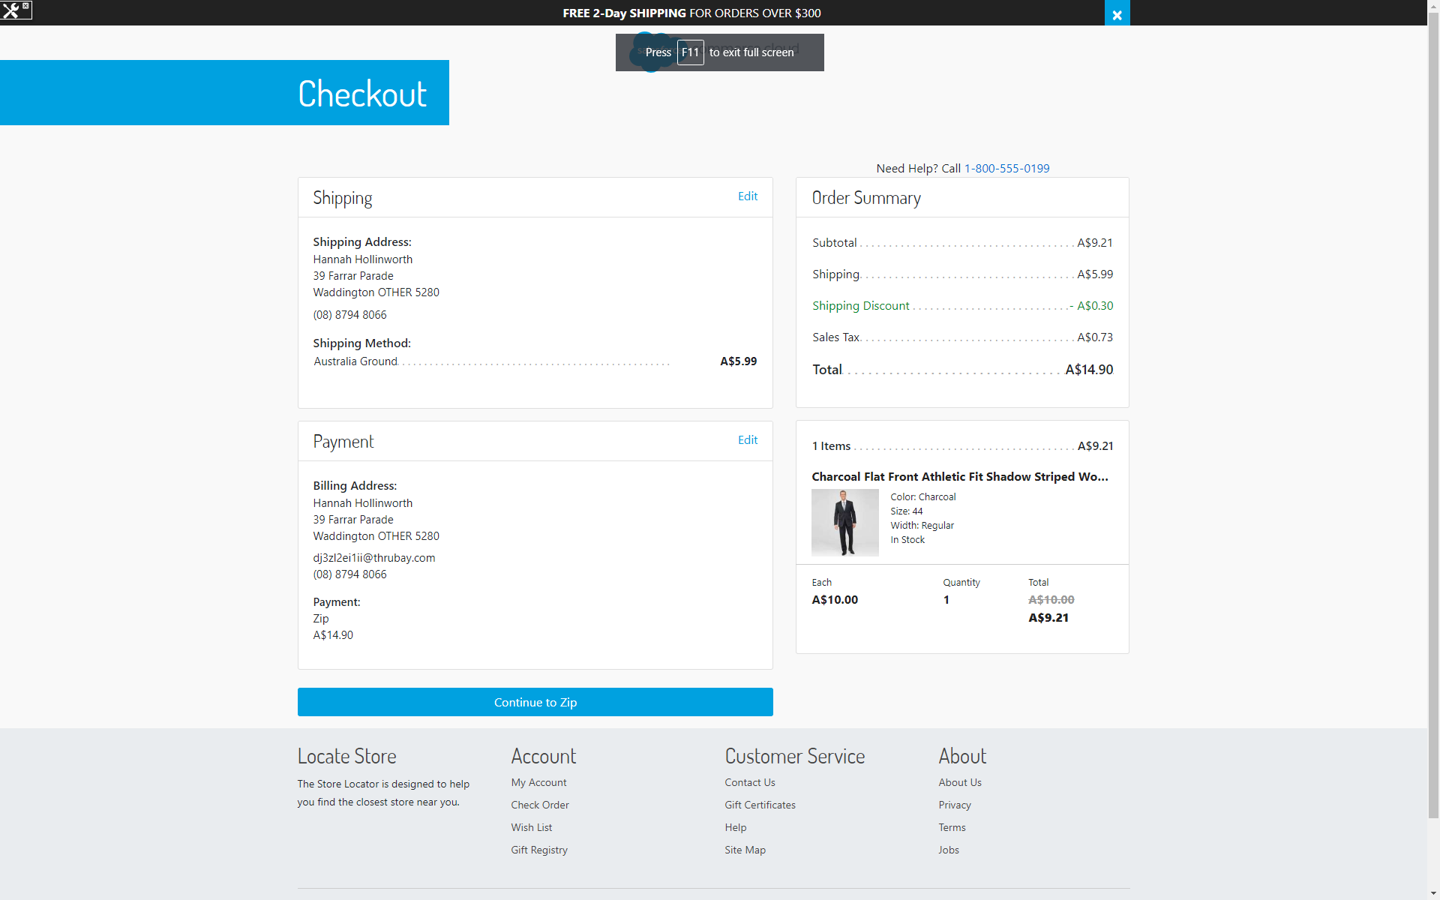

When the button is clicked, the Zip lightbox will load (we have configured Zip to open in a lightbox).

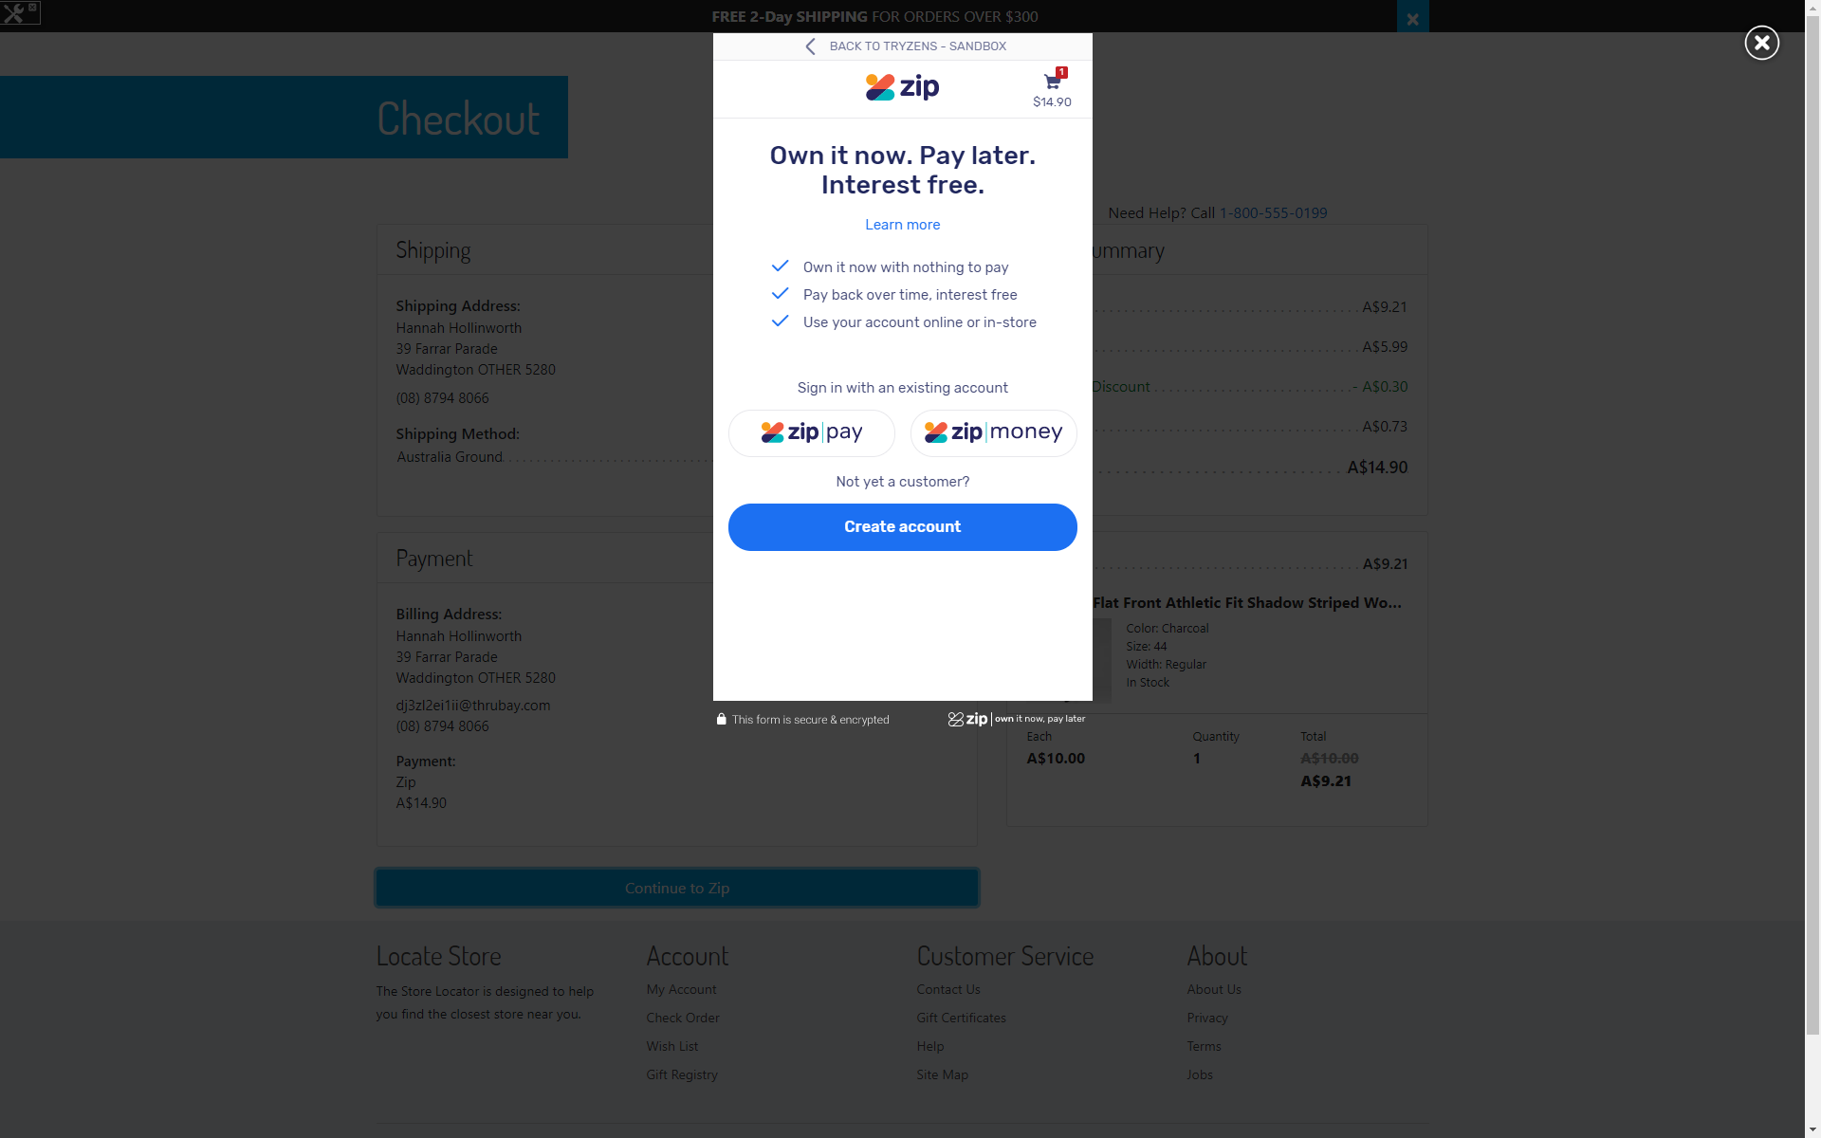

### Choose a Zip Product

Zip currently offers two products: Zip Pay and Zip Money. The first one is used for orders of amounts under 1000$. For bigger orders, Zip Money can be used. In this test, we are going to select Zip Money and use an already existing account to complete the order.

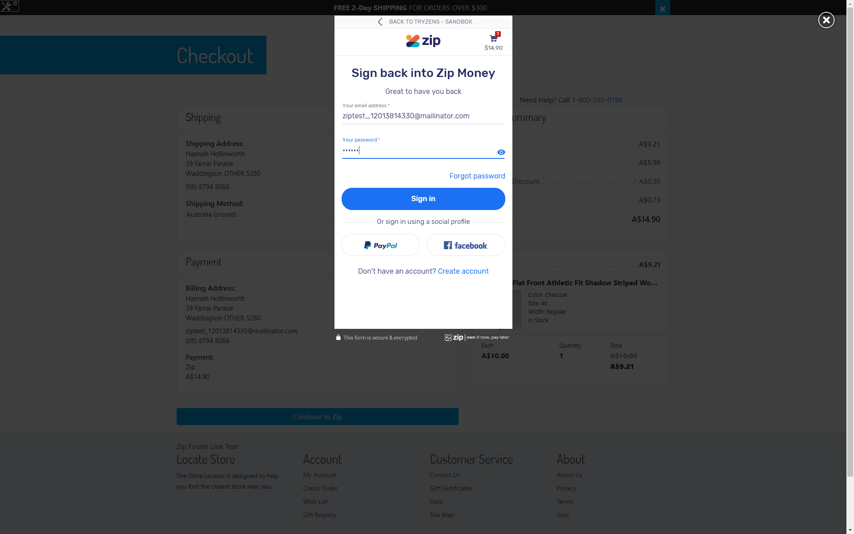

Enter your account credentials and click “*Sign In*”.

### Confirm Order with Zip

Once logged in, you should see payment summary same as the one in the checkout.

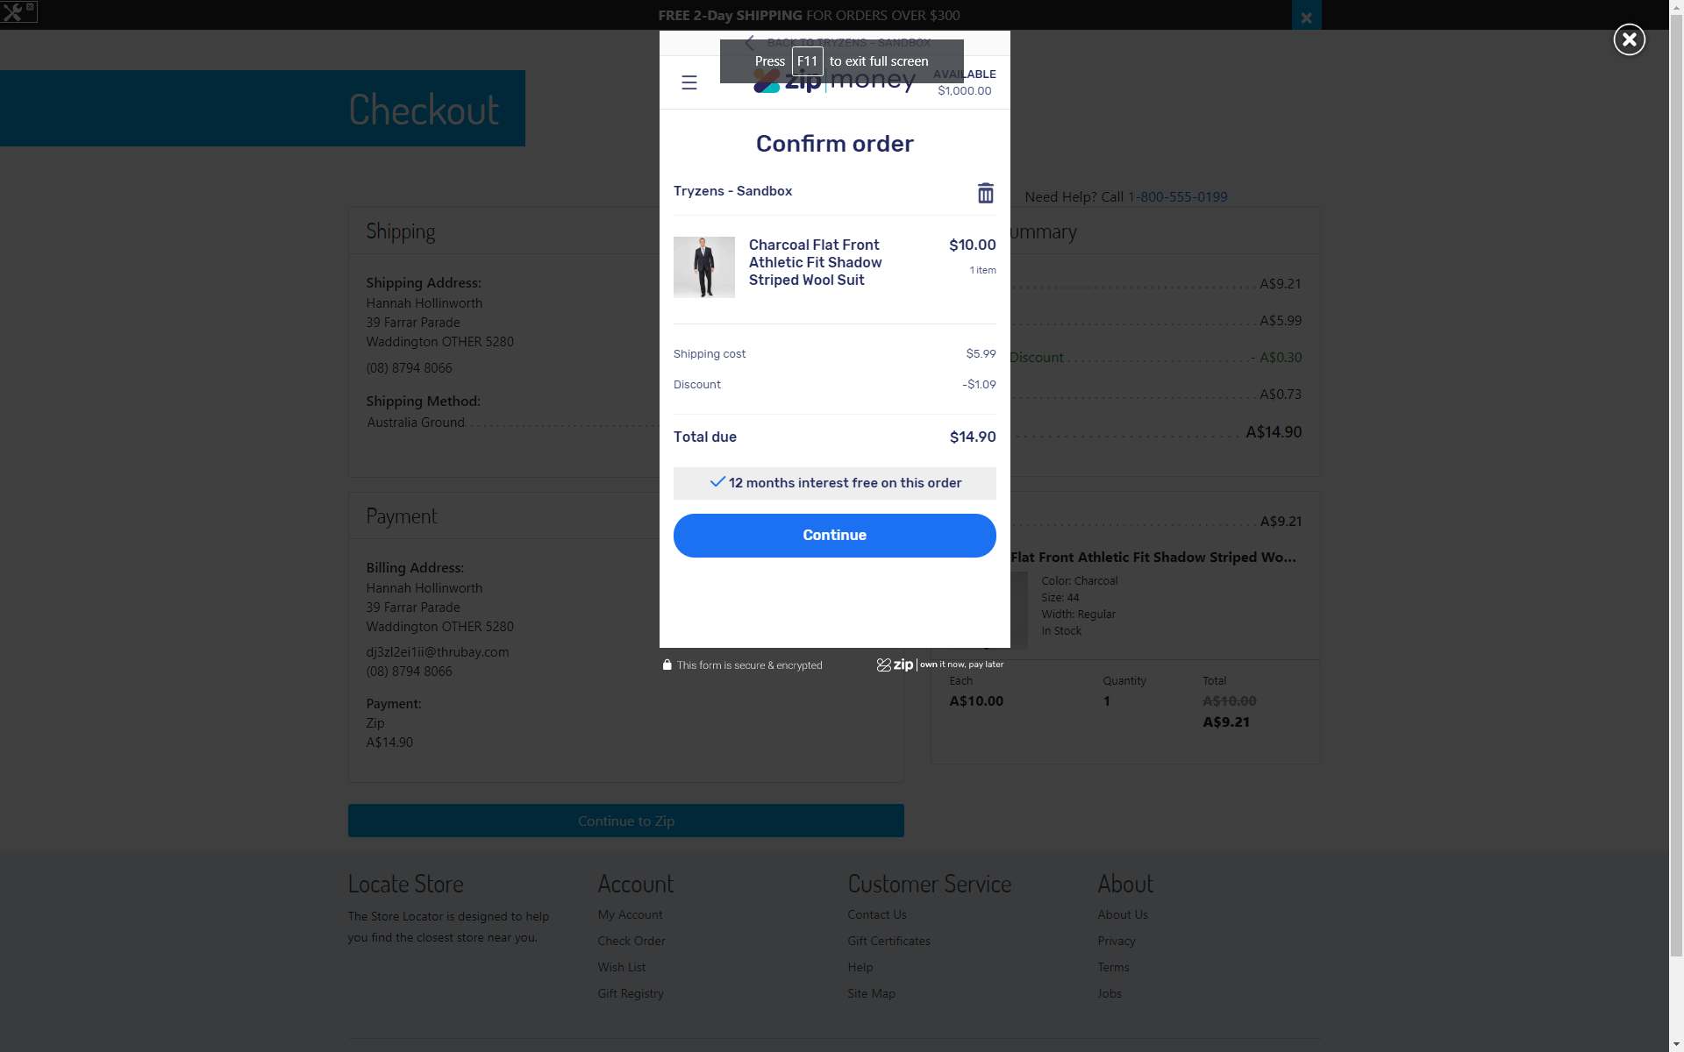

Click “*Continue*”.

### Check Order Confirmation Page

The order has been approved by Zip. You should be redirected back to the “*Thank You*” confirmation page. You should see an additional “*Zip Receipt Number*” which has been generated by Zip. This receipt number is also sent with the confirmation email.

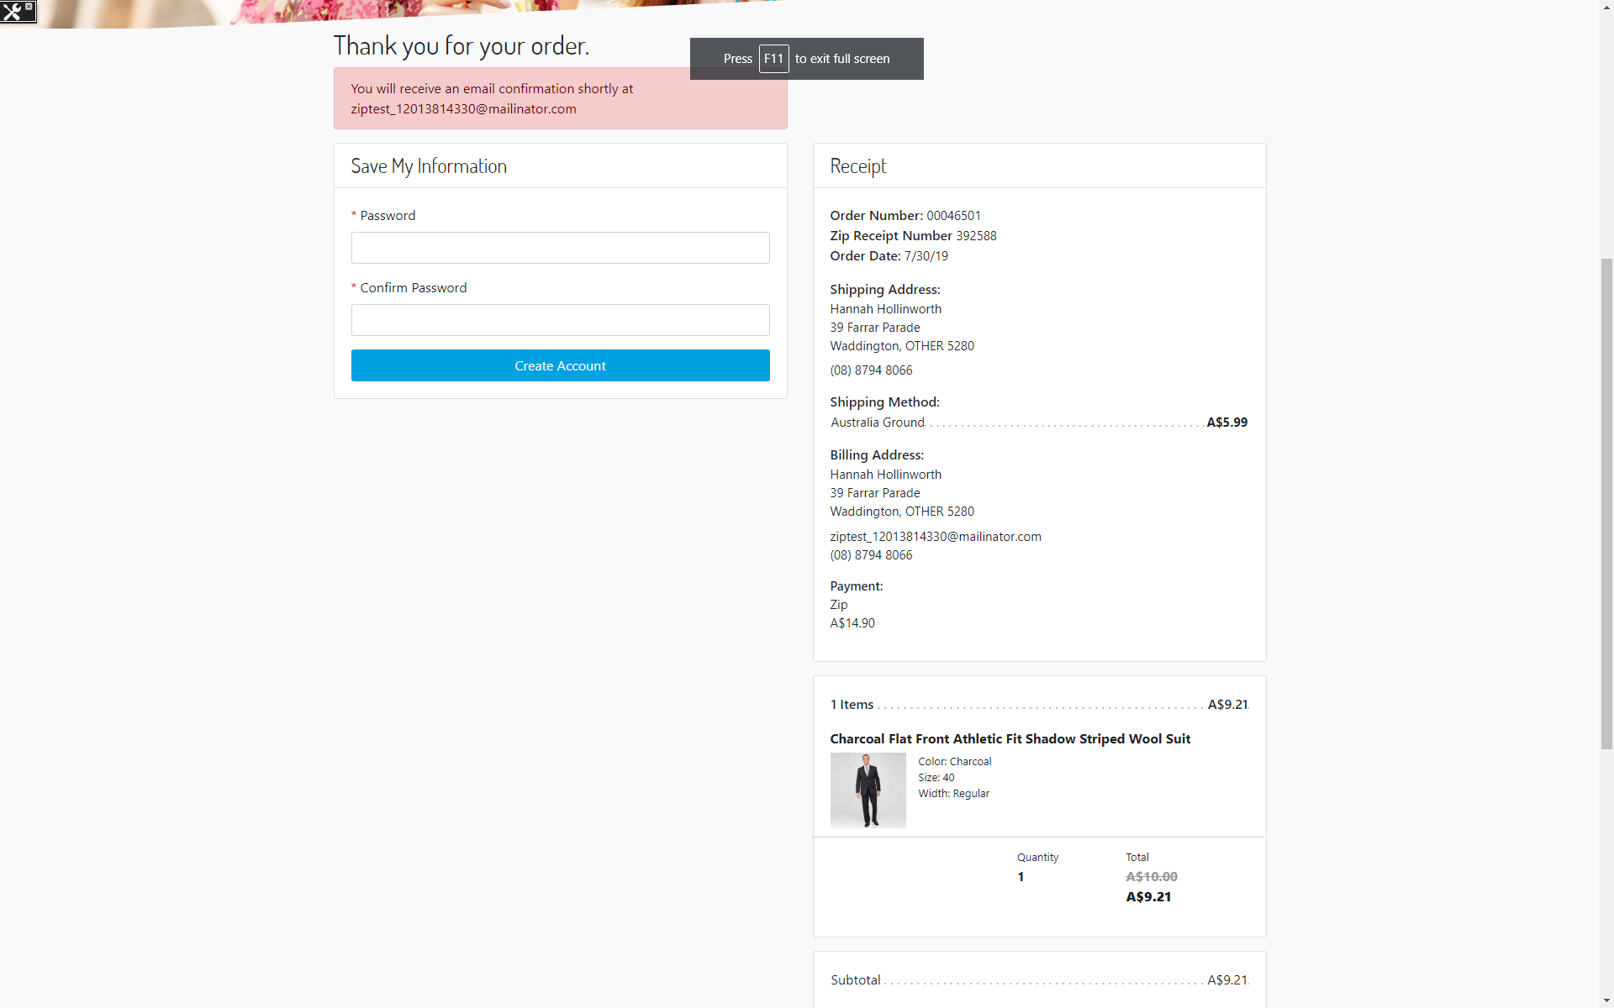

### Check Confirmation Email

The confirmation email sent should also contain Zip Receipt Number as shown below.

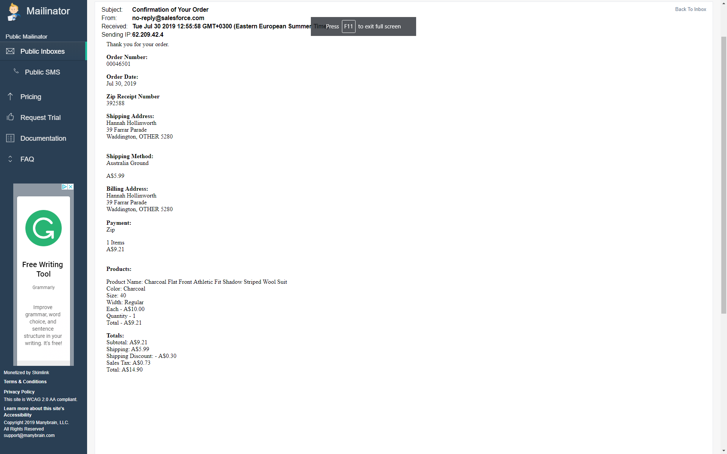

### Check Order in Business Manager

Last, we visit the Order in Business Manager. From “Merchant Tools”, please select “Orders”. Type the order number in the search box and click “Find”.

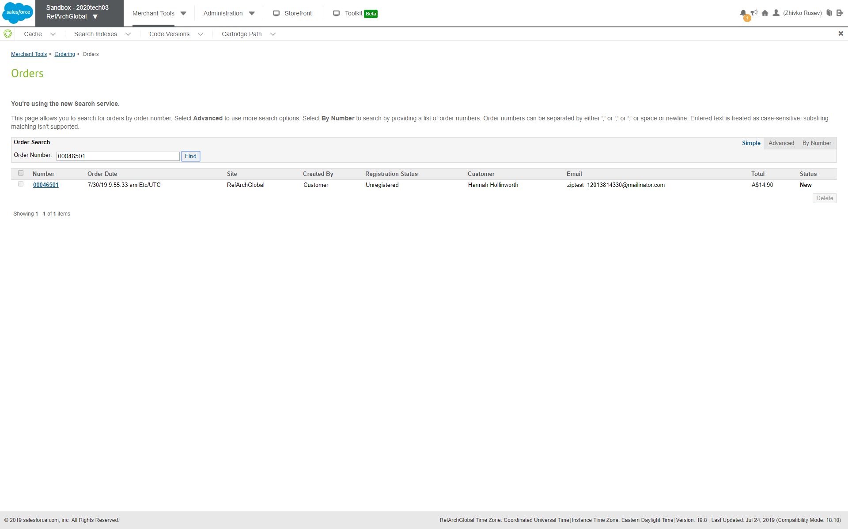

Click on the order number.

The View Order screen appears and we should be at the “General” tab. Here, you should see status “*Confirmed*” since we have enabled auto-capture in the beginning of the test.

Click on the “*Payment*” tab. There are couple of things we are looking for. Payment status should be “Paid”. The processor for the full payment should be “*Zip*”. In addition to that, Zip Email and Zip Phone contain the email and phone number from billing step during checkout. You should be seeing the Zip Receipt Number same as in the confirmation page and email. The Zip Charge ID is an identifier of the charge created when order has been approved. At last, we are seeing “Is Automatic Capture” to confirm the charge has been automatically captured.

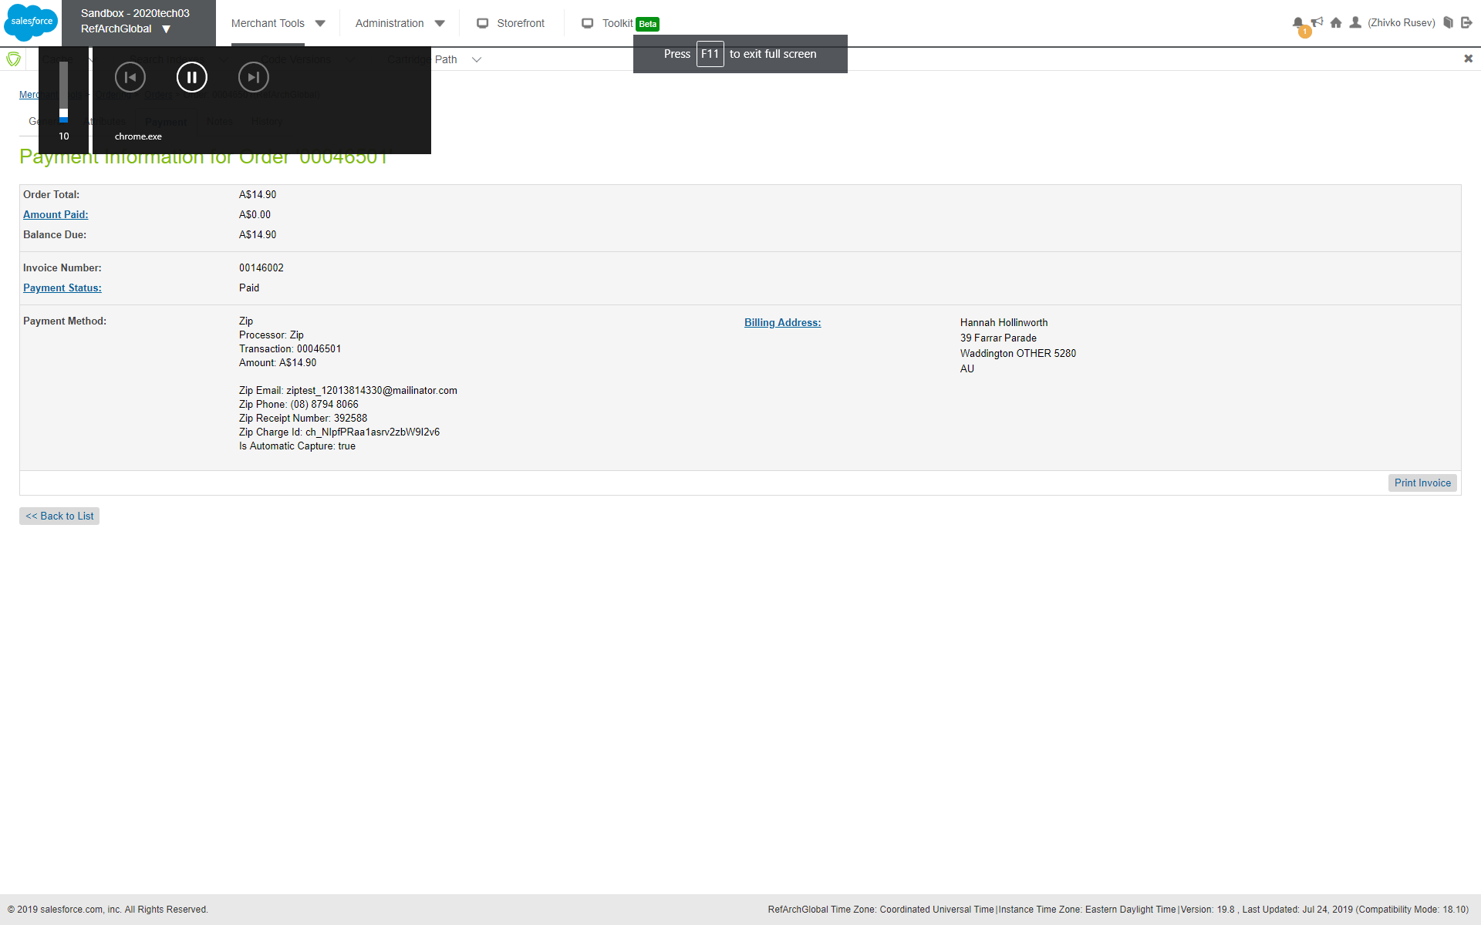

### Visit Zip Merchant Dashboard to confirm Order

As an additional, optional step, we have visited the merchant dashboard to check for the approved order.

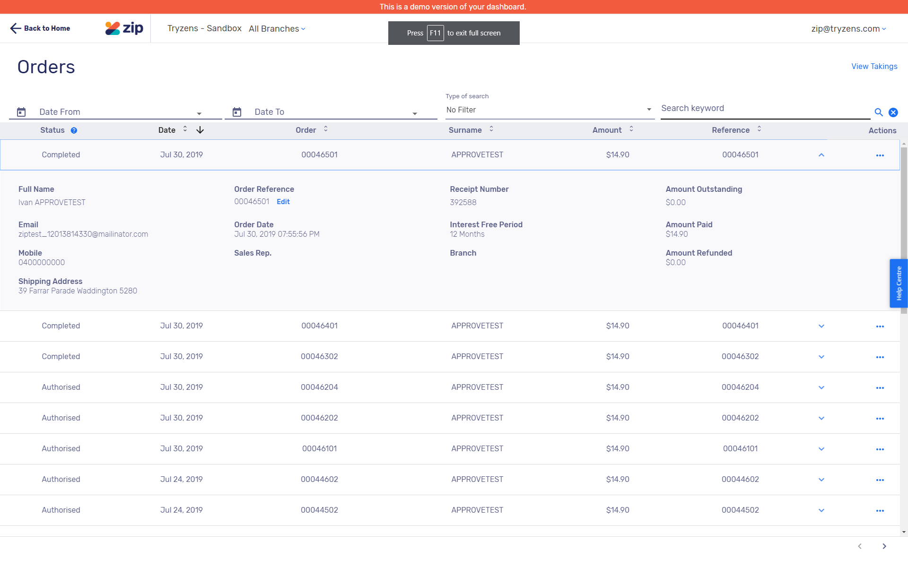

## Checkout with Zip standard flow as Customer

The second test is a successfully completed checkout by a logged in customer who has requested to save Zip as a payment method for future use.

### Prerequisites

For the second test, a prerequisite is to enable tokenization (if not already done) from within the site’s preferences.

Another prerequisite is to have a ready customer account.

### Visit Website and Choose Locale

Once the configuration is done in the Business Manager, you should visit the website. Zip is available for certain countries only. For this test, we are using the “*English (Australia)*” locale from the drop-down.



### Add Product

We have selected a simple product from a category “*Mens – Clothing – Suits*”. We have added 1 to cart.

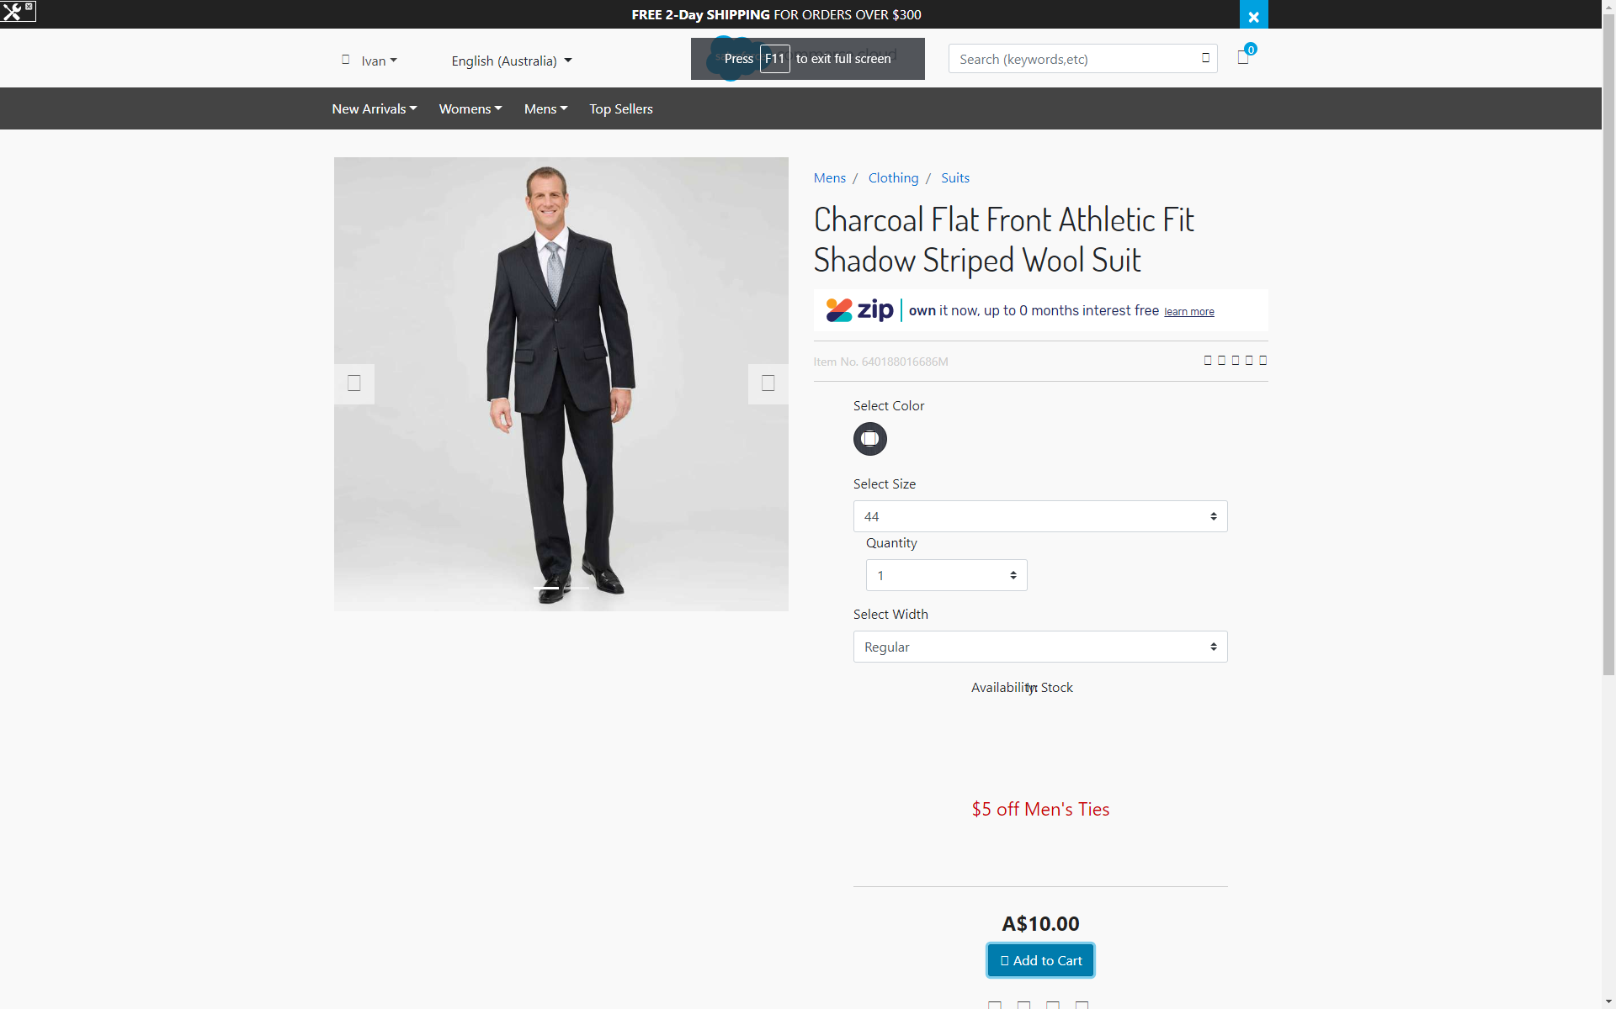

### Proceed to Checkout as Guest and Enter Shipping Information



We used the following test address:

|  |  |
| --- | --- |
| First Name | Hannah |
| Last Name | Hollinworth |
| Address 1 | 39 Farrar Parade |
| Country | Australia |
| State | Other |
| City | Waddington |
| Zip Code | 5280 |
| Phone Number | (08) 8794 8066 |

Any shipping method should work. For the test, we are using *Australia Ground*.

When done, click “*Next: Payment*”.

### Enter Billing Information and Choose Zip as Payment Method

Enter an email and a phone number.

We used the following test phone and email:

|  |  |
| --- | --- |
| Phone Number | (08) 8794 8066 |
| Email | ziptest_12013814330@mailinator |

Choose Zip payment method.

Make sure that you check the “*Remember my Zip details…*” checkbox.

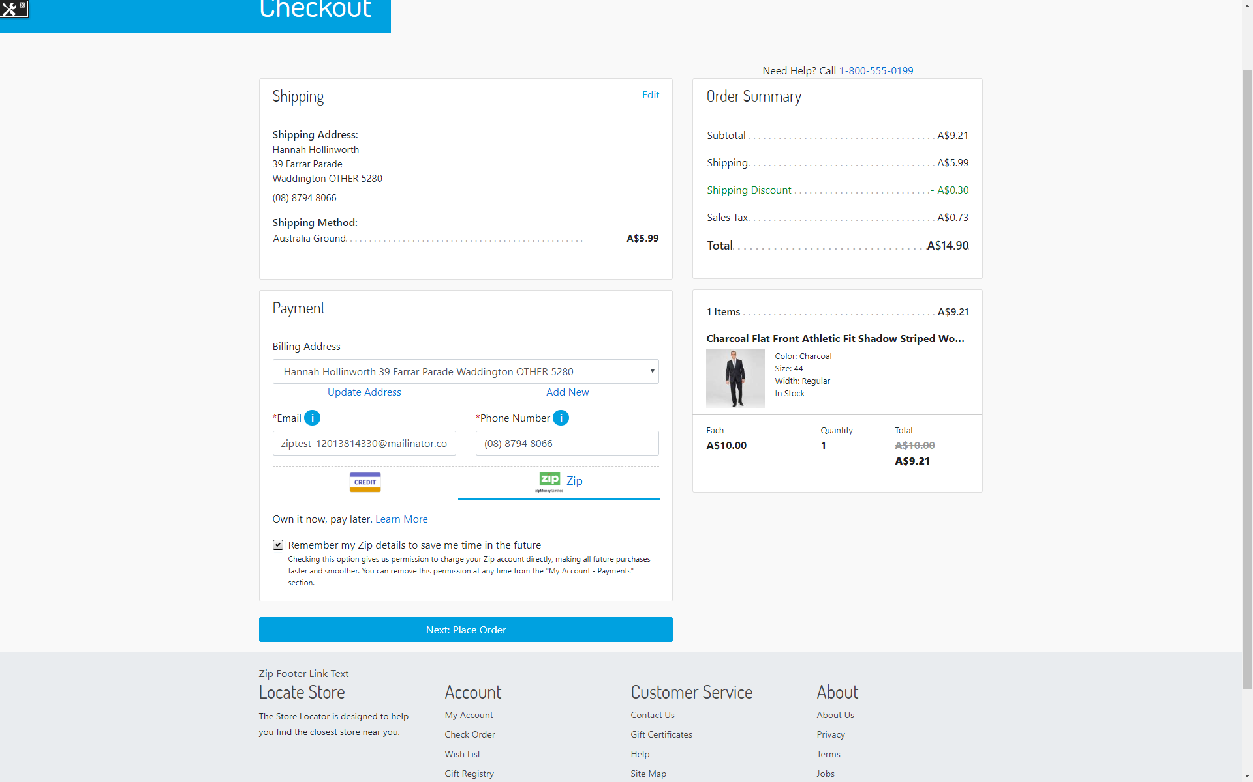

Click “*Next: Place Order*”.

### View Payment Summary and Continue To Zip

On the payment summary step, the payment is “Zip” and there should be a button “*Continue To Zip*”.

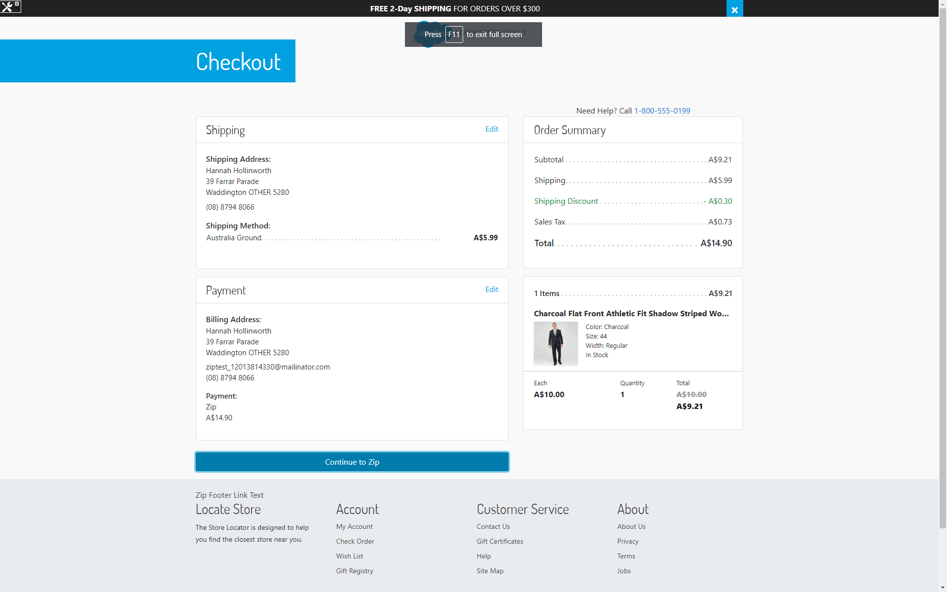

### Complete Order with Zip

As in the first test, we will complete the order with Zip, going through the checkout experience. Once again, we have used Zip Money with a test account. Since we are already logged in Zip, we can just click the “*Continue*” button to confirm the test order.

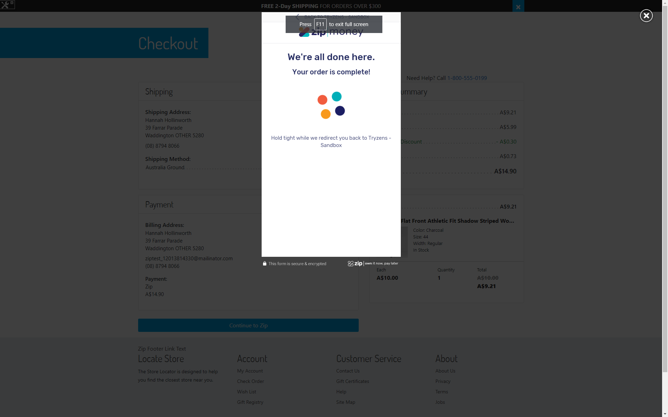

### Check Order Confirmation Page

The order has been approved by Zip. You should be redirected back to the “*Thank You*” confirmation page.



### Check Token in My Account

Navigate to “*My Account*” section in the website.

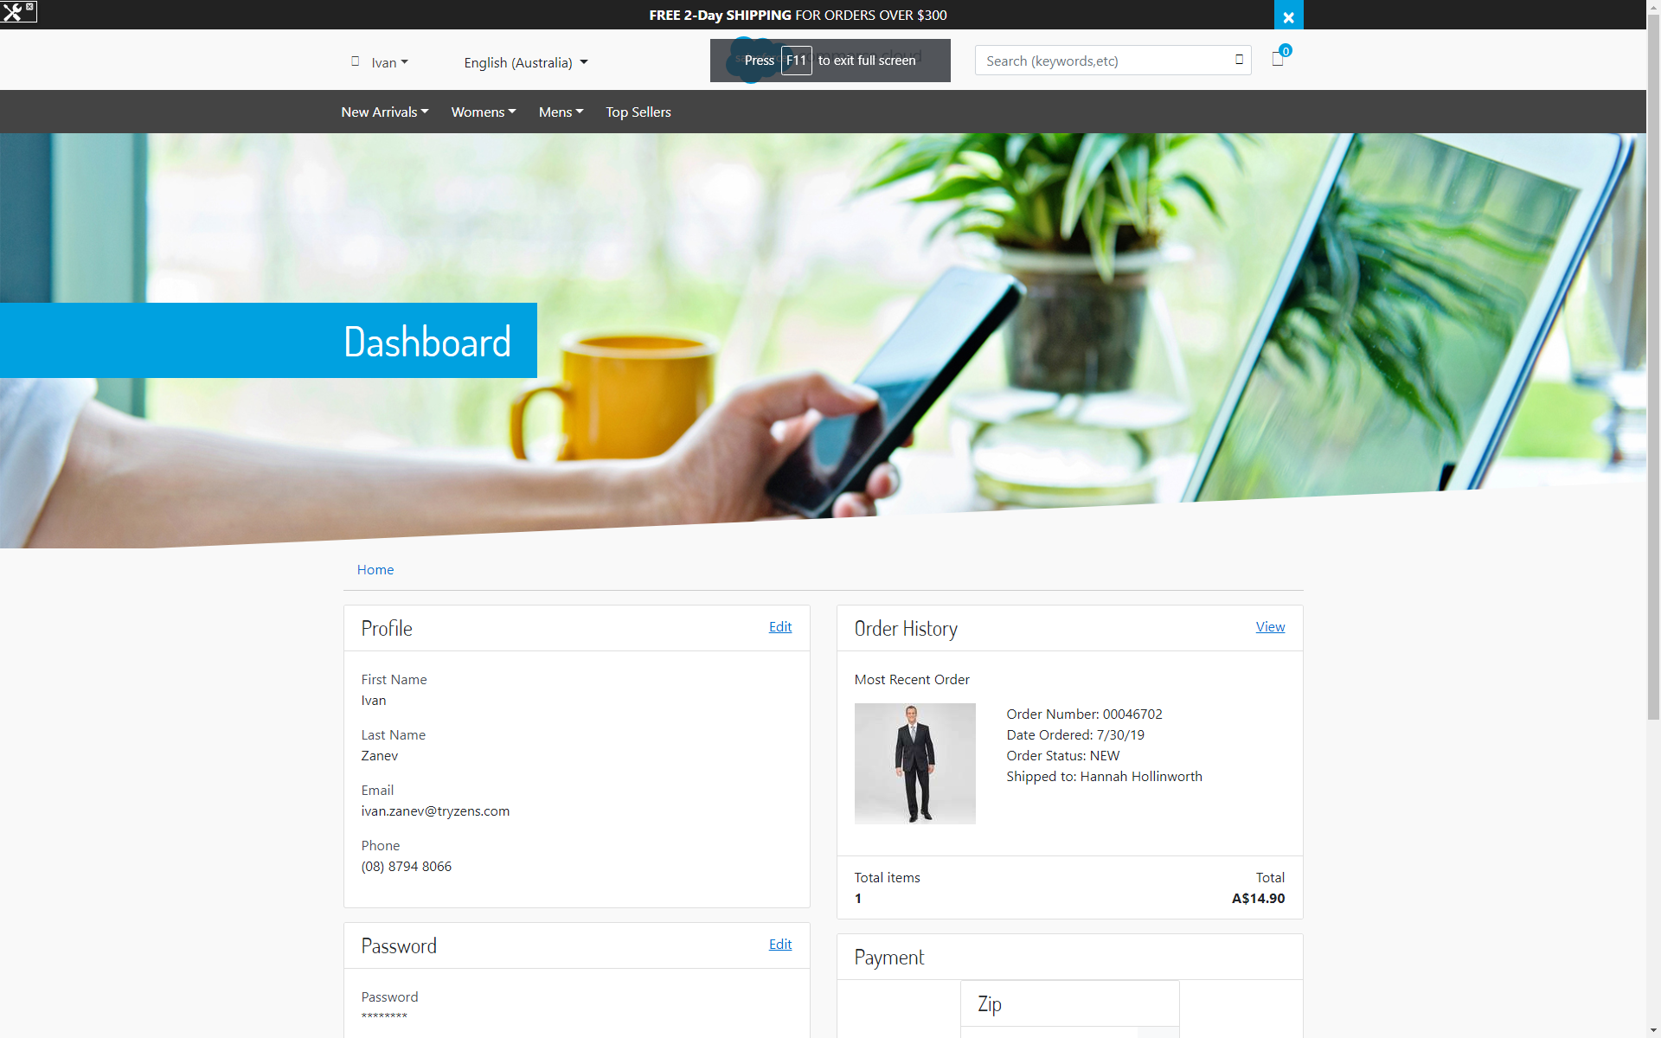

Within the customer’s dashboard, you should be seeing “*Zip*” in the “*Payment*” section.

## Checkout with an Existing Customer Token

The third and final test uses an existing customer token.

### Prerequisites

* An existing customer token, which can be obtained by completing the second test.
* A single product must have been added to cart.
* We are using the same website and locale as in the previous, second test. Those are “*RefArchGlobal*” and the “*English (Australia)*” locale.
* In checkout, a valid shipping address must have been added (or selected from customer’s addresses book).

### Complete billing step and Pay with Zip

Once all the prerequisites have been fulfilled, you should be on the billing step.

Enter your email and phone number and choose “*Zip*”.

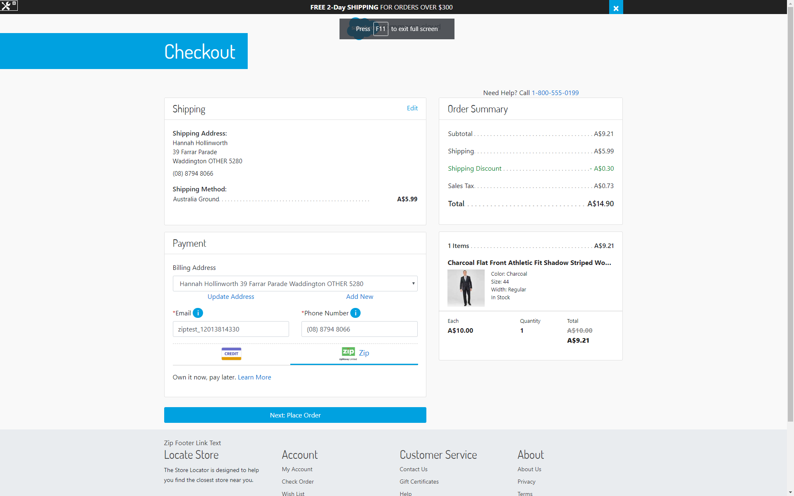

This time, since a token has been already saved in previous test, a checkbox does not appear.

Click “*Next: Place Order*”.

### Check Order Summary and Place Order

The payment summary screen should not show “*Continue To Zip*” button. Instead, “*Place Order*” button is available to quickly place an order using the existing token without going through a new checkout experience.

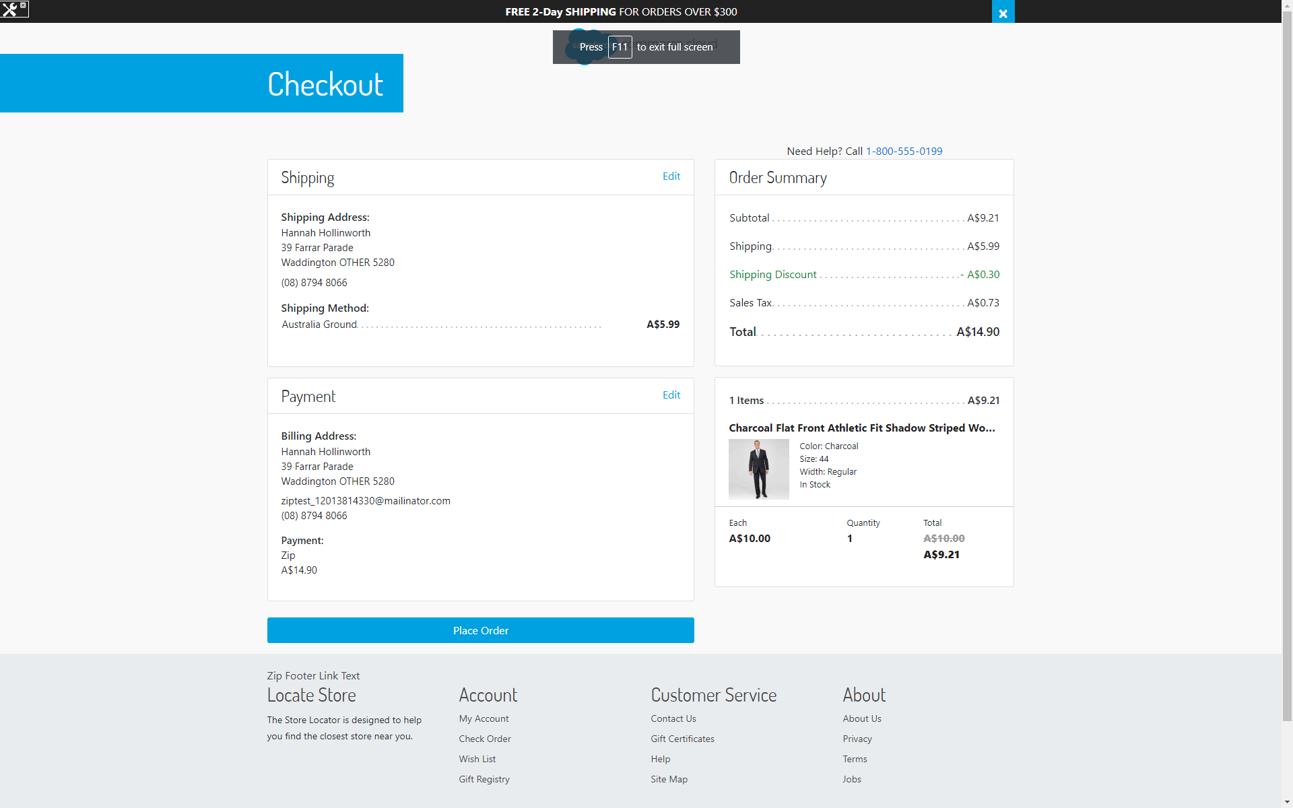

Click “*Place Order*”.

### Check Order Confirmation

You should be redirected straight to the order confirmation screen with a message for a successful order.

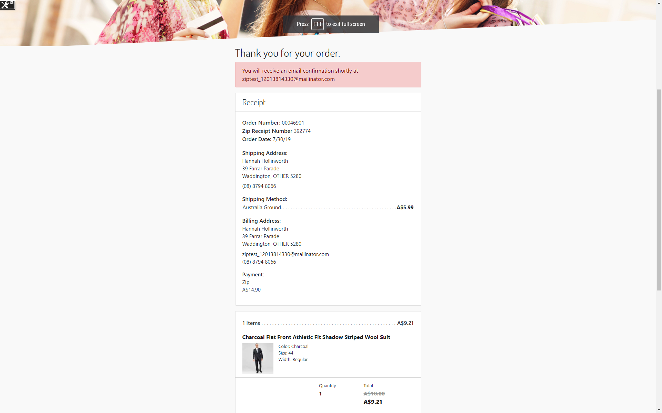

# Operations, Maintenance

## Data Storage

### Zip Tokens

Zip tokens are stored within Order system objects for the period of their existence. This is true, if tokenization is enabled (by the merchant).

Zip tokens are also stored within a customer’s wallet, if the customer has requested to save Zip as a payment method during checkout. Such a token is removed only when the customer removes the payment instrument from within their My Account area.

## Availability

In case of problems with the connection to Zip Payments please contact the Zip Payments support department.

Please supply as much information as possible (Merchant account, time, order number, Zip Payments reference etc.). Also, please check the log file mentioned above.

## Support

In case of problems with the integration, missing features, etc. please contact the Zip Payments support department or your zipMoney account manager.

# User Guide

This section of the integration guide describes how merchants can configure the features of this integration.

## Business Manager

### Configure Zip Payments Processor

#### Enable/Disable Lightbox

To configure this feature, the merchant needs to use the setting located in “Merchant Tools – Custom Preferences – Zip – Lightbox”.

#### Activate Production Mode

To configure this feature, the merchant needs to use the setting located in “Merchant Tools – Custom Preferences – Zip – Zip API Mode Production”.

(when the merchant is ready for production, the API Key also needs to be updated.)

#### Set API Key

To configure this feature, the merchant needs to use the setting located in “Merchant Tools – Custom Preferences – Zip – Zip API Mode Production”.

#### Enable/Disable Automatic Capture

To configure this feature, the merchant needs to use the setting located in “Merchant Tools – Custom Preferences – Zip – Automatic Capture”.

#### Enable/Disable Zip Tokenization

To configure this feature, the merchant needs to use the setting located in “Merchant Tools – Custom Preferences – Zip – Zip Tokenization”.

### Configure Zip Payment Method

#### Update Payment Method Logo

The Zip payment method logo can be updated.

The setting is in “Merchant Tools – Ordering – Payment Methods”. On the payment method screen, choose “Zip”. Then, use the “Image” setting and upload a new logo.

#### Allowed Countries

The setting is in “Merchant Tools – Ordering – Payment Methods”. On the payment method screen, choose “Zip” and then use the “Countries” setting to configure allowed countries. Zip payment method will only be available for those countries you select.

#### Min/Max range for each currency

The setting is in “Merchant Tools – Ordering – Payment Methods”. On the payment method screen, choose “Zip” and then use the “Min/Max Payment Ranges” setting for each currency.

### Configure Zip Marketing

For Zip Marketing features to be available to customers, couple of things should be kept in mind:

* A marketing key should be configured (read below).
* At least one Zip payment method should be enabled from the Business Manager.

#### Configure Marketing Key

The setting is within the Site’s custom preferences: “Merchant Tools – Custom Preferences”. Choose “Zip” group and within the setting is called “Zip Marketing Key”.

#### Enable/Disable Zip Marketing Widget on Cart Page

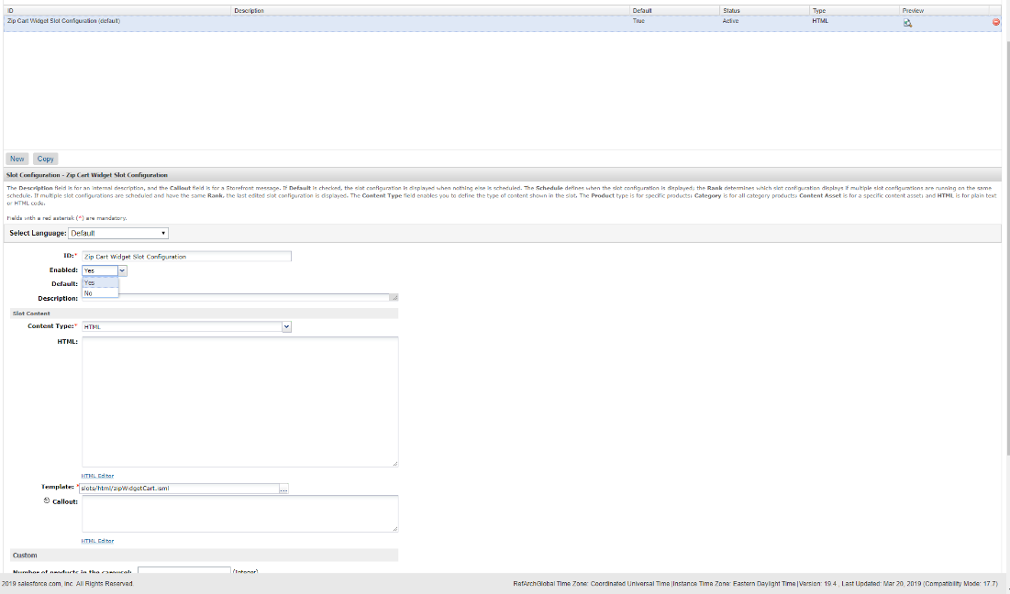

The widget is implemented as a content slot “zip-cart” with one slot configuration called “Zip Cart Widget Slot Configuration”. In order to enable the widget, please use the “Enabled” setting and set to “Yes”.

#### Enable/Disable Zip Marketing Widget on Product Detail Page

The widget is implemented as a content slot “zip-pdp” with one slot configuration called “Zip Product Widget Slot Configuration”. In order to enable the widget, please use the “Enabled” setting and set to “Yes”.

#### Configure Zip Footer Link Text

The Zip Footer Link has been implemented as a content asset called “zip-footer-link”. The merchant may enable/disable it as well as change its appearance and text for different locales via the Business Manager. Make sure you have added the content asset following the steps in the Installation section.

#### Configure Zip Footer Logo

The Zip Logo has been implemented as a static asset placed in the same folder as this integration guide named zip-footer-icon.png file.

### Configure Zip Checkout

#### Configure Zip Payment Declined Message

The message appearing on payment stage when Zip payment is declined is configurable via a content asset: “zip-declined”.

### Configure Thank You Page (Order Confirmation)

#### Configure Zip Pending Message Custom Styling

The styling of the Zip Pending Application Message appearing on Thank You Page can be configured via the Site Preferences, Zip Preference group. The preference is called “Zip Pending Message Styles”.

The default configuration for this preference generates the following styling:

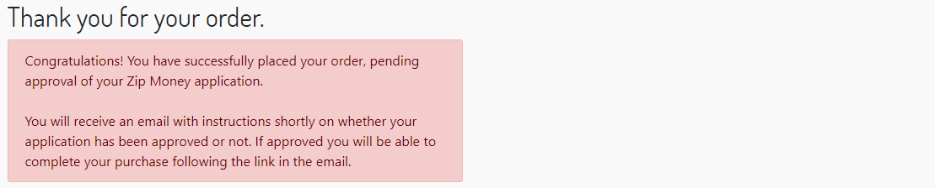

You can customize the appearance of this message box by changing the custom preference mentioned above. To change the colors, You can use an online color picker.

### Configure Zip API Client

#### Configure Retries in case of General Errors

In case of general errors, the Zip API Client will retry requests according to configuration values specified in the Zip Service Profile. To access those configuration values, navigate to “Administration – Operations – Services” and then select “Profiles” tab. Choose the “zip.http.service” profile.

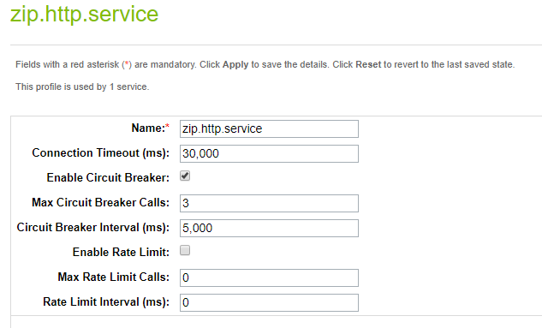

The **Max Circuit Breaker Calls** determine the number of attempts the Service is going to make in case of general errors. The **Circuit Breaker Interval** determine the interval in which those attempts will be made.

General errors are:

* Issues at initial connection.
  + Unknown host
  + Connection timeout
  + Connection refused
* Protocol-specific errors, such as HTTP 500 - internal server error or HTTP 503 - service unavailable.
* Exceptions explicitly thrown as part of the service call

# Known Issues

None.

# Release History

|  |  |  |
| --- | --- | --- |
| **Version** | **Date** | **Changes** |
| 19.1.0 |  | Initial release |